
Company
Logotype

Cone Beam Computed Tomography- Report



Porur Dental X-rays & CBCT

Patient Name : Miss. Vidhya | Date of Report : 02.07.2024
Age/ Gender : 24 years/ Female | Region of Interest : CBCT Maxilla
Referring doctor: Dr. Toothsi | Indication : Impacted tooth
Clinical Notes: Nil
PATIENT INFORMATION

CBCT Maxilla provided
CBCT – IMAGE DETAILS

RADIOGRAPHIC INTERPRETATION

- Deciduous teeth present in the maxillary arch: 53.
- The tooth 13 appears to be within the alveolar bone, distally tipped with its crown in contact with the radicular portion of 12, 53 and root of 13 in contact with the medial wall of right maxillary sinus and floor of nasal cavity.
- The tooth 13 is positioned such that it involves the labial cortical bone.
- The floor of the right maxillary sinus is present with hyperdense mucosal thickening.
- The left maxillary sinus is present with mucosal thickening along the medial wall and floor.

RADIOGRAPHIC IMPRESSION


- Impacted tooth: 13
- Retained deciduous tooth: 53.
- Bilateral maxillary sinusitis.

IMAGES FOR REFERENCE

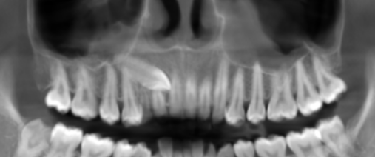
PANORAMA VIEW

3-DIMENSIONAL VIEW

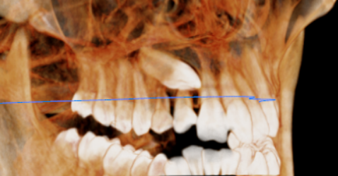

CROSS- SECTIONAL IMAGES

13 REGION | 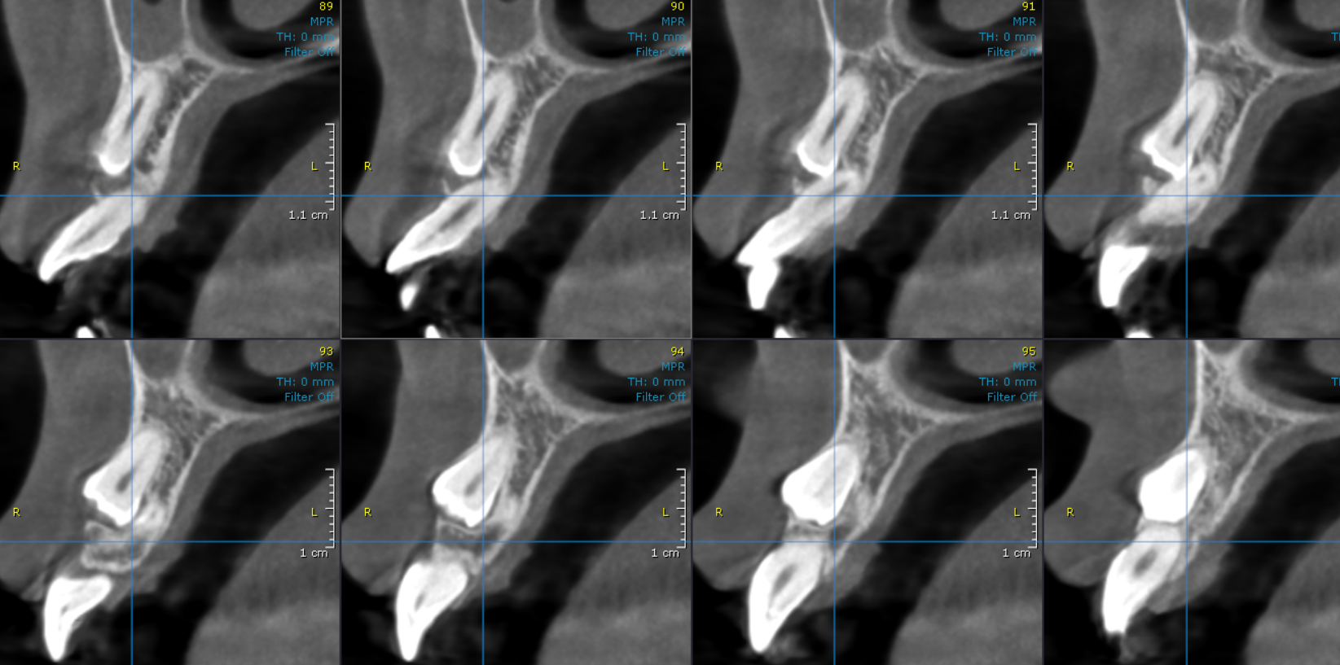
**** End of report ****

